Rheumatic Heart Disease Detection Using Deep Learning fromSpectro-Temporal Representation of Un-segmented Heart Sounds

Rheumatic Heart Disease (RHD) is an autoimmune response to a bacterial attack which deteriorates the normal functioning of the heart valves. The damage on the valves affects the normal blood flow inside the heart chambers which can be recorded and listened to via a stethoscope as a phonocardiogram. However, the manual method of auscultation is difficult, time consuming and subjective. In this study, a convolutional neural network based deep learning algorithm is used to perform an automatic auscultation and it classifies the heart sound as normal and rheumatic. The classification is done on un-segmented data where the extraction of the first, the second and systolic and diastolic heart sounds are not required. The architecture of the CNN network is formed as an array of layers. Convolutional and batch normalization layers followed by a max pooling layer to down sample the feature maps are used. At the end there is a final max pooling layer which pools the input feature map globally over time and at the end a fully connected layer is included. The network has five convolutional layers. This current work illustrates the use of deep convolutional neural network using a Mel Spectro-temporal representation. For this current study, an RHD heart sound data set

In propose paper author is using heart sound dataset from PHYSIONET website and this dataset contains heart signals data , this heart signals get training with Classic ML algorithms and then heart recording voice data will get trained with deep learning algorithm.

Raw signal features get trained with ML and Deep learning.

Existing methods : machine learning (RF)

Proposed Method Deep Nural Network

To implement this project we have designed following modules

1. Upload Dataset: using this module we will upload dataset to application
2. Dataset Preprocessing: using this module we will extract audio recording features of heart sounds from dataset and then normalize values
3. Run ML Model: using this module we will extract features from dataset and then train with Random Forest Classic ML model and then apply test data to calculate its prediction accuracy
4. Run DL Model on Raw Features: using this module we will extract RAW features from recording and then train with deep learning model and then this model will be applied on test data to calculate its accuracy
5. Predict RHD from Test Heart Sound: using this module we will upload Test Heart Sound file and then deep learning classifier model will predict weather given recording file is Normal or Abnormal

Below is the dataset screen used in this project

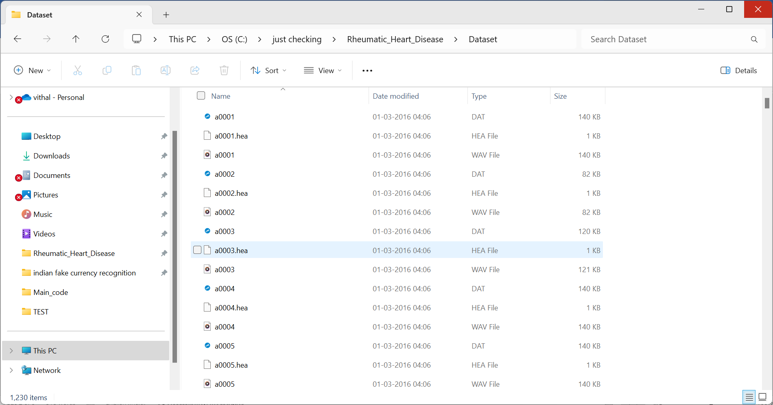

In above screen we have 3 files where .hea file contains class label as Normal or Abnormal and .dat file contains data of Heart signals and .wav file contains heart sound recording and by using all files we will train all algorithms

Results of proposed model are ,

To run project double click on ‘run.bat’ file to get below screen

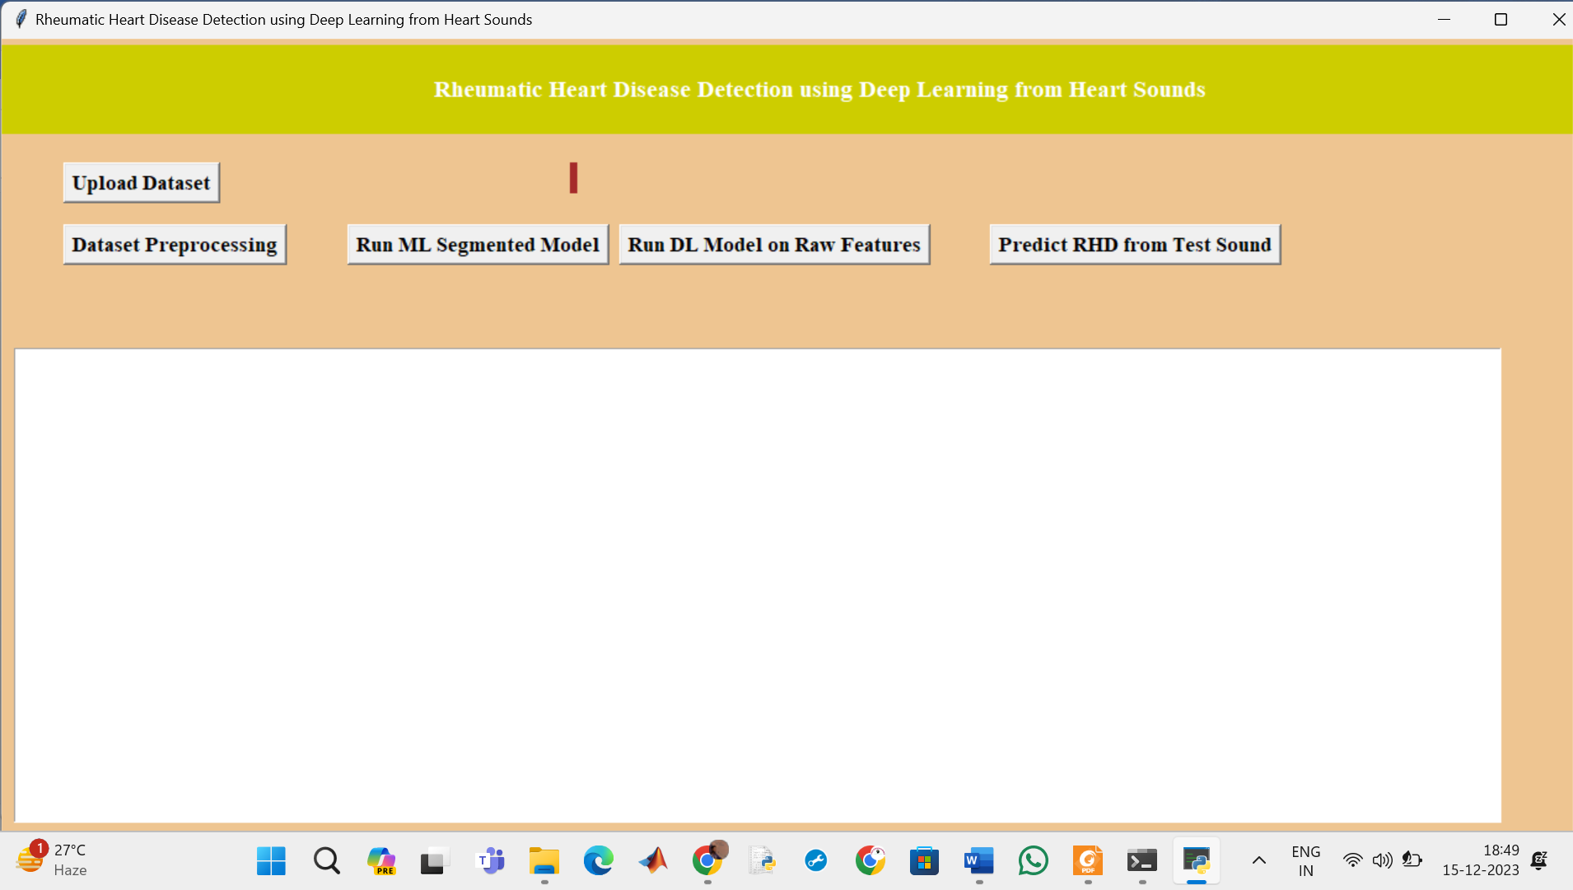

In above screen click on ‘Upload Physionet Dataset’ button to upload dataset

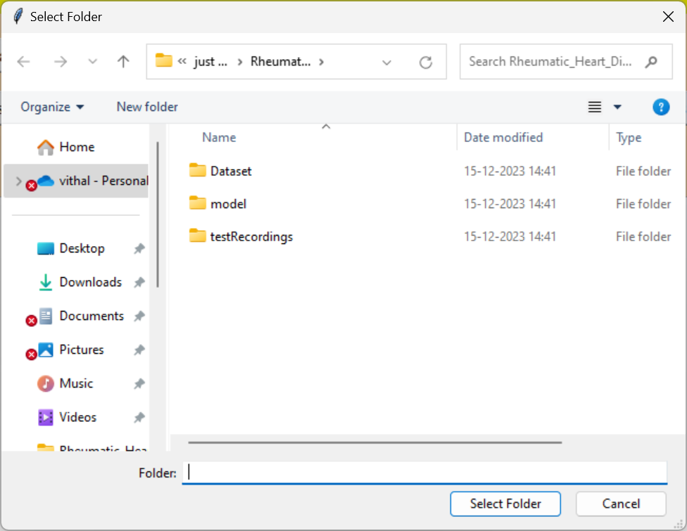

In above screen selecting and uploading ‘Dataset’ folder and then click on ‘Select Folder’ button to load dataset and to get below output

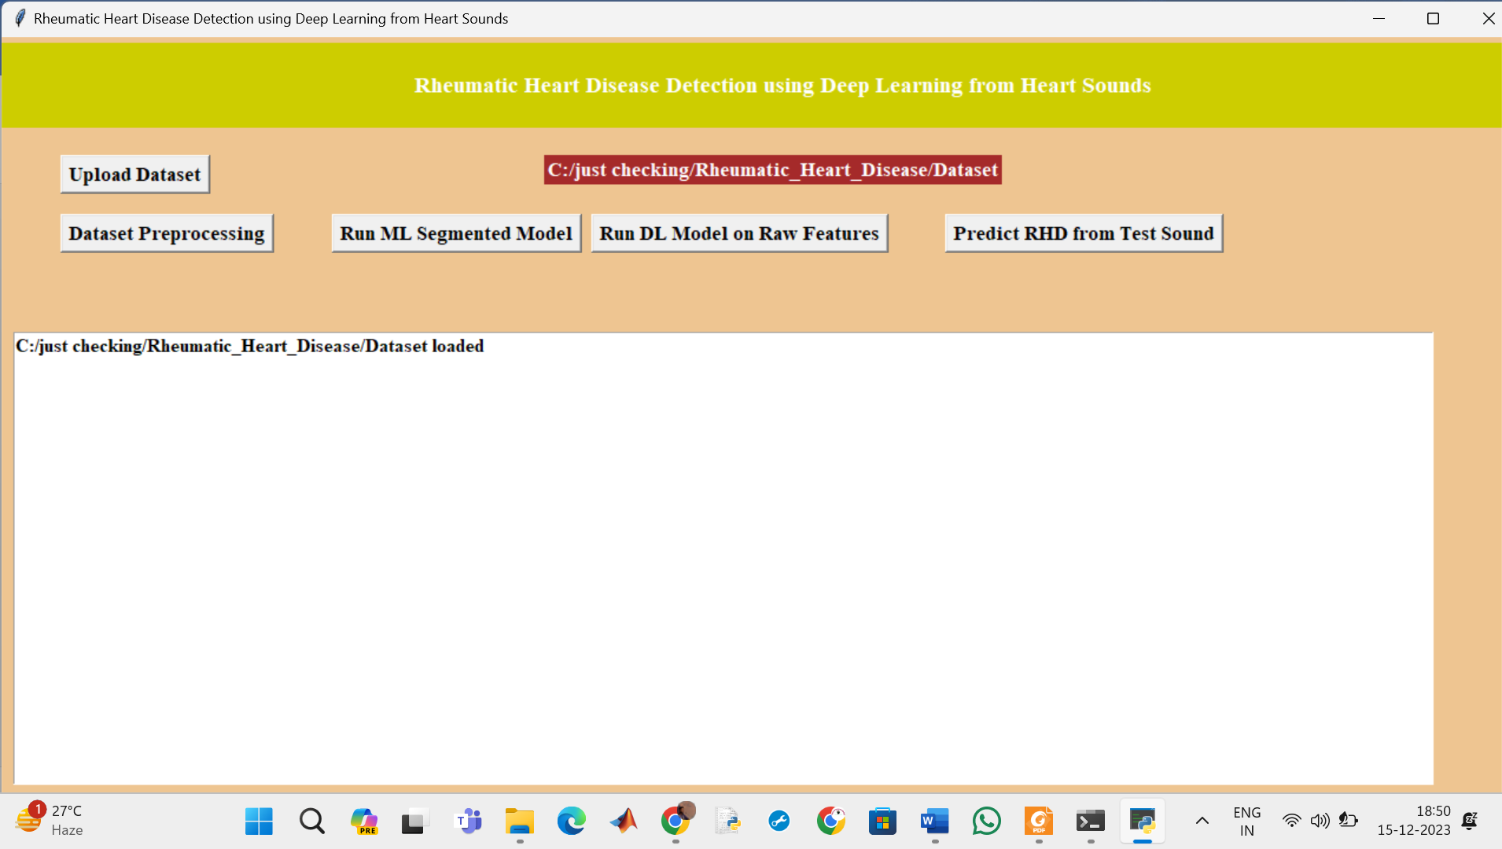

In above screen dataset loaded and now click on ‘Dataset Preprocessing’ button to read all dataset file and then extract features from it

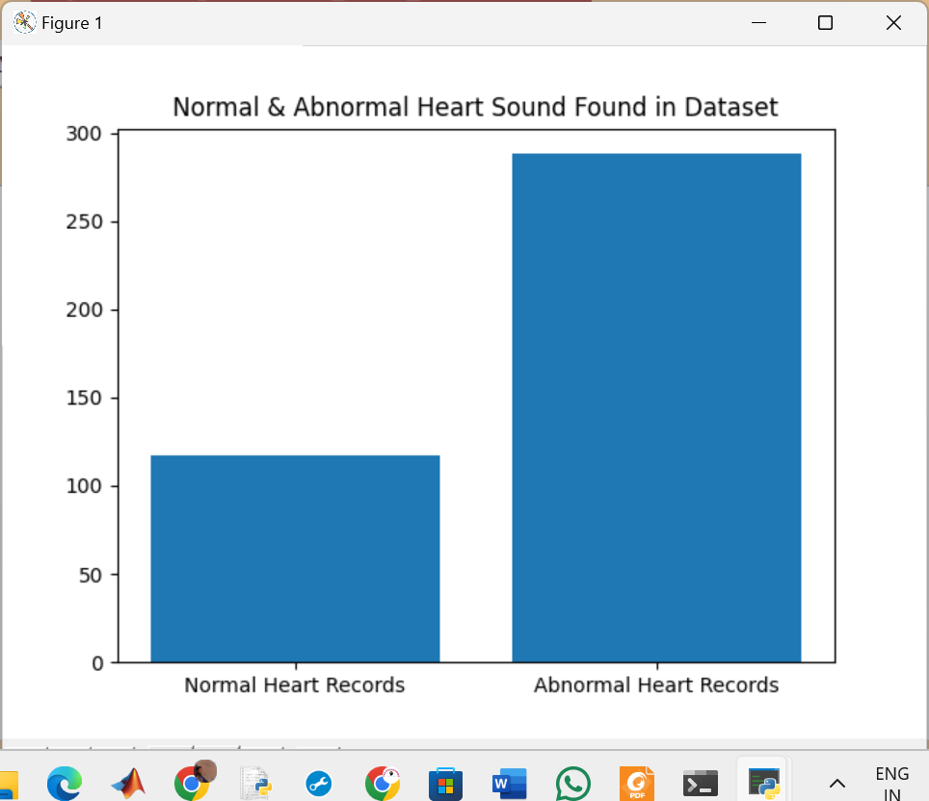

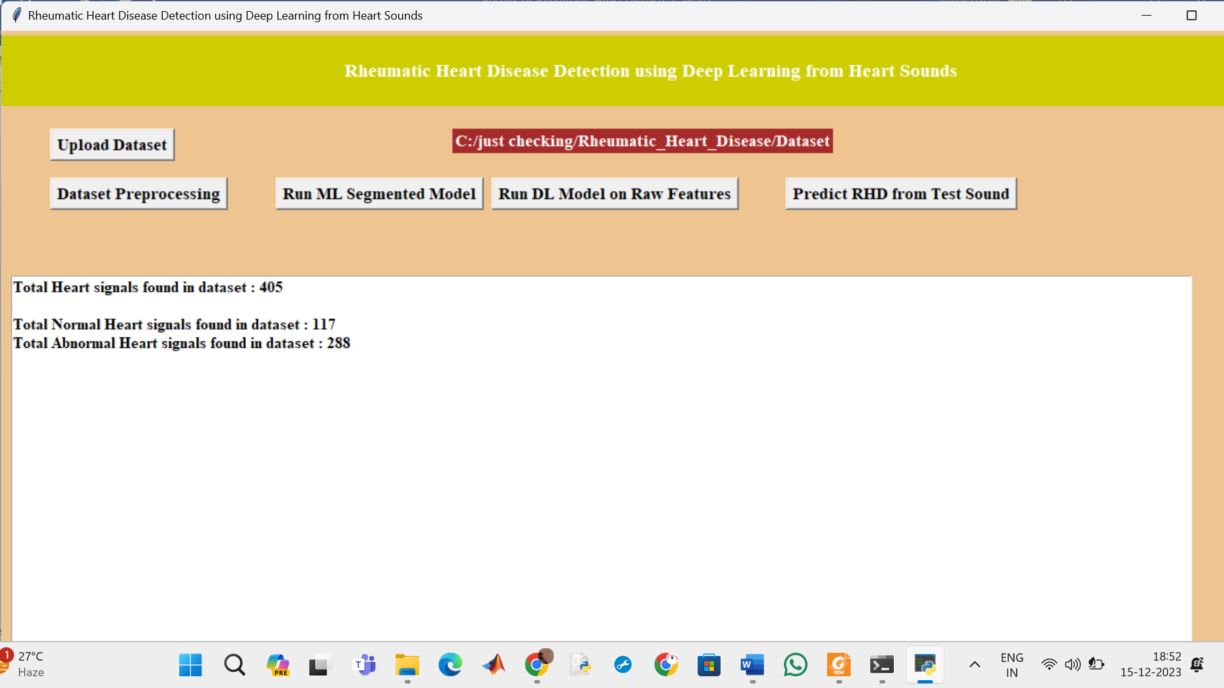

In above screen we can see dataset contains 405 heart sound files from 405 different person and 117 are the Normal sound and 288 are abnormal and in graph x-axis represents normal or abnormal and y-axis represents number of persons for normal or abnormal. Now close above graph and then click on ‘Run ML Model’ button to train Classic ML model on above dataset and get below output

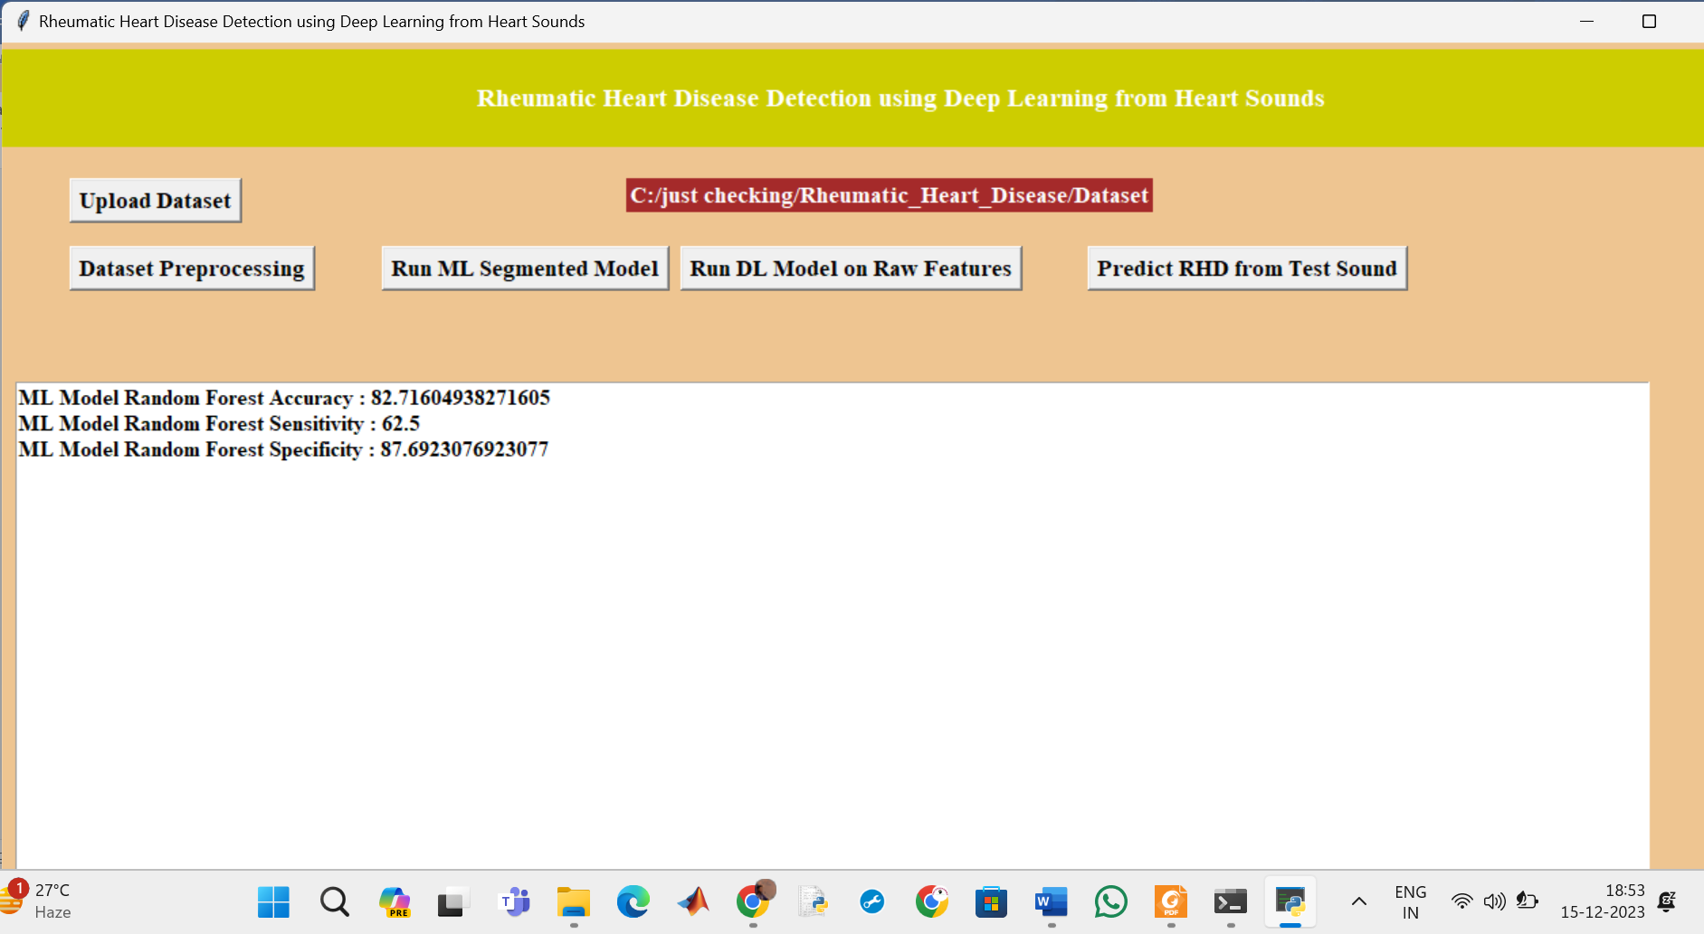

In above screen with Classic ML we got nearby 90% accuracy

and now click on ‘Run DL Model on Raw Features’ to get below output

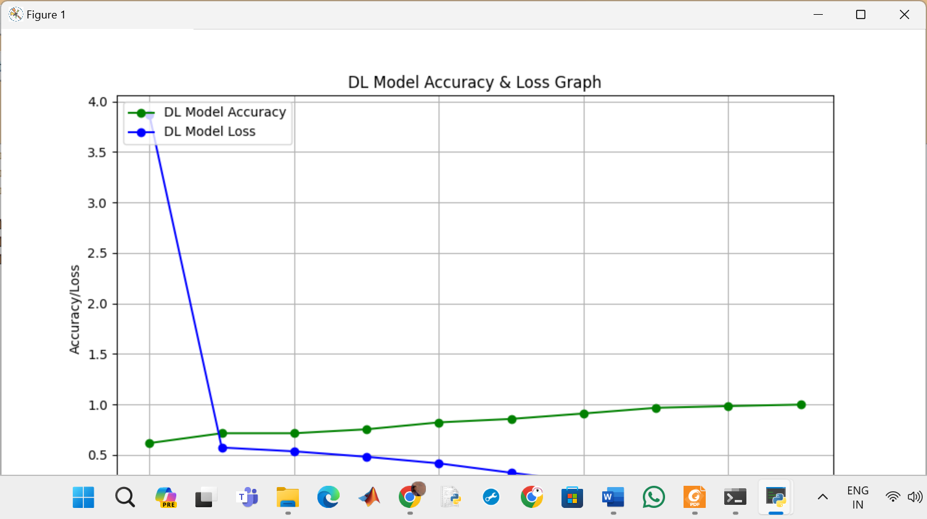

In above screen with DL model we got 93% accuracy and in graph x-axis represents epoch or iterations and y-axis represents accuracy or loss values and green line represents accuracy and blue line represents LOSS and we can see with each increasing epoch accuracy got increase and loss got decrease and now close above graph.

In above graph x-axis represents algorithm names and y-axis represents accuracy, sensitivity and specificity and in all algorithms Recording model has got high accuracy. Now close above graph and then click on ‘Predict RHD from Test Sound’ button to upload test sound file and get predicted output as Normal or Abnormal

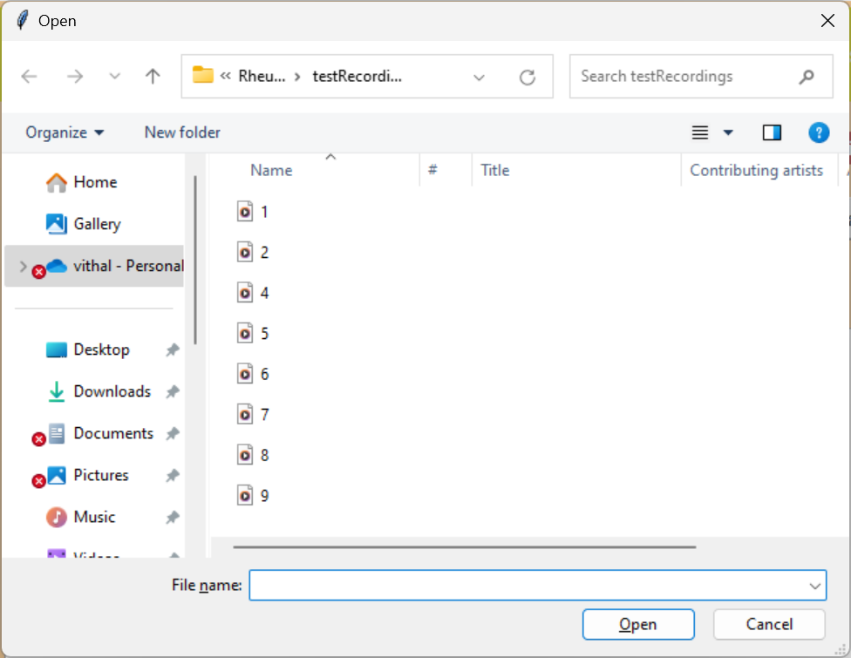

In above screen selecting and uploading ‘1.wav’ file and then click on ‘Open’ button to get below output

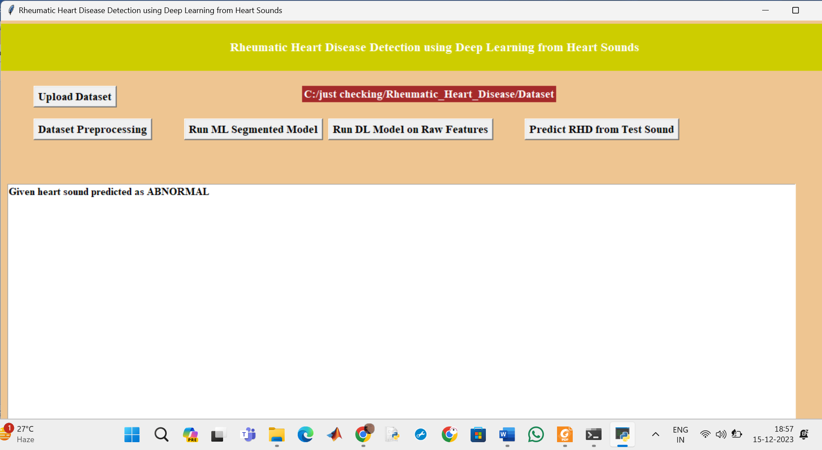

In above screen uploaded heart sound file predicted as ABNORMAL and similarly you can upload other files and test

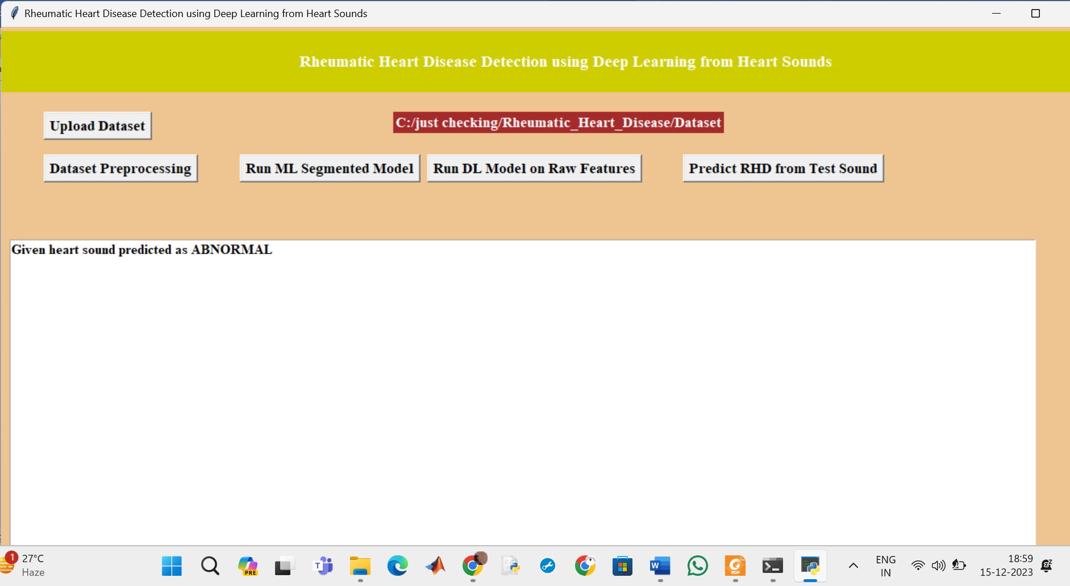

For 2.wav’ file below is the output

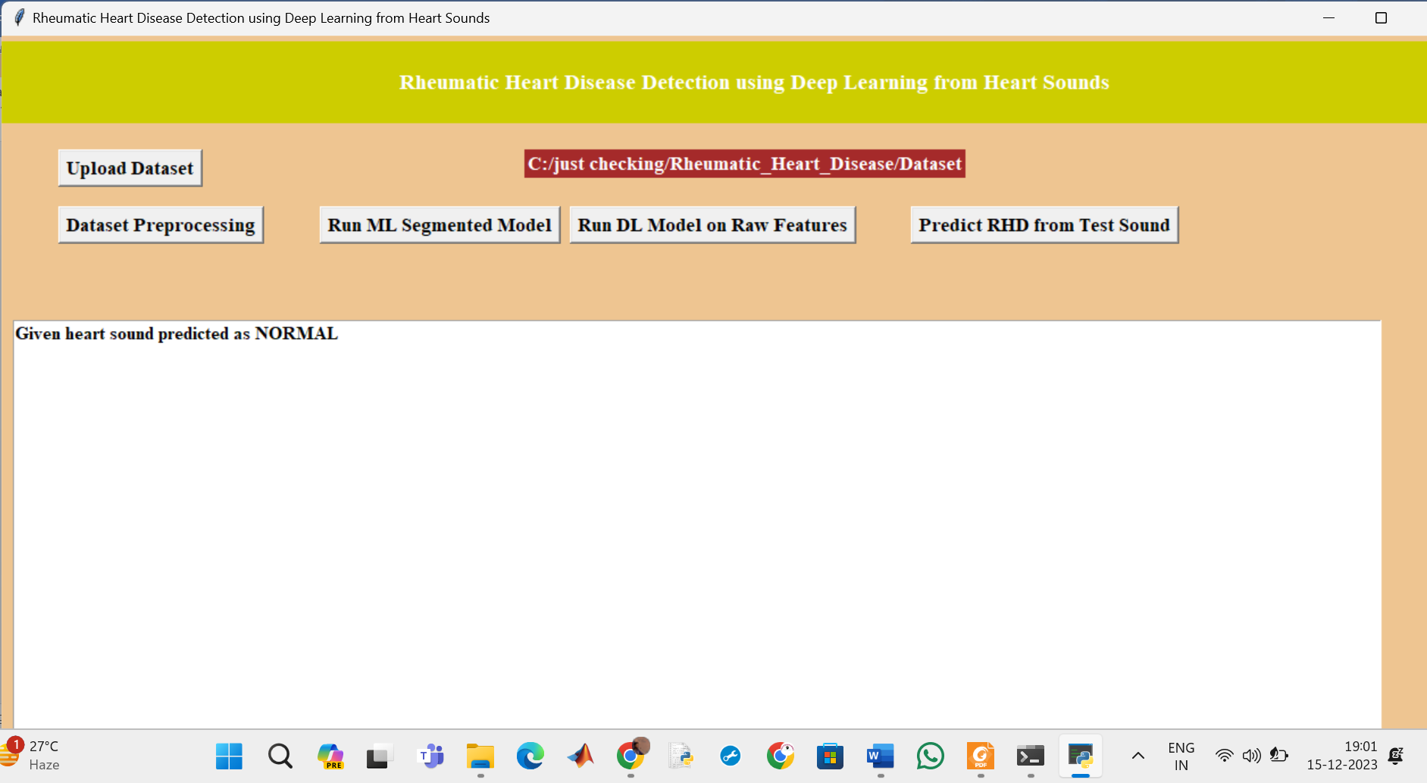

Like this we can test speech signal